Background Check Form

Please fill in the details with utmost attention, as these shall be verified by the Company and/ or by its
authorized representatives.

Please Affix Your Passport Size Photograph

All details are compulsory.

Personal Details
Name of Applicant: Last Middle First
Chavan Gurappa Pradip
Date of Birth (dd/mm/yy):07/06/1995 |  | Place of Birth: Narsinhpur
Sex:Male |  | Nationality: Indian
Father’s Name: Gurappa Motiram Chavan |  | Passport No.: T6292408
Home Phone: | Office Phone: | Mobile: 7620233186

Residential Addresses
Permanent Address: a/P Narsinhpur Tal-Wlawa,Dist-Sangli

City: Islampur | State: Maharashtra |  | Pin Code:415409 | Phone No.:9637867421
Duration of Stay: From (mm/yy) To (mm/yy)  June 1995 june 2016 |  | Nature of location: Rented Own Other (Specify)

Current Address:
flat no 404
Renuka Residency ,Canal road, lane no 4 ,Karvenagar,pune,411052
City:pune | State:Maharashtra |  | Pin Code:411052 | Phone No.:7620233186
Duration of Stay: From (mm/yy) To (mm/yy)  July 2016 till date |  | Nature of location: Rented Own Other (Specify)

Education Details
Qualification | Name & Address Of School / College/ Institute | Name & Address of  Board / University  to which the School / College / Institute  is affiliated to |  | Course Attended  (Morning/ Evening/ Correspondence) | Marks (%) CGPA  &  Class | Dates Attended |  |  |  |  | Roll Number/ Registration Number/ Exam Seat Number
 |  |  |  |  |  | Year of enrolment (mm/yy) |  |  | Year Passed (mm/yy) |  | Roll Number/ Registration Number/ Exam Seat Number
10th | Sanguru ashram shala islampur | Shivaji university | morning |  | 85.64 |  | 2009 | 2010 |  | F069625
12th | Sadguru junior college islampur | Shivaji university | Morning |  | 63.85 |  | 2011 | 2012 |  | X018689
Graduation | Sanjay Ghodawat Instituite,Atigre,Kolhapur | Shivaji university |  | Morning | 61 | 2012 |  |  | 2016 |  | 50326
Degree:

Discipline:

Full Time

Part time
Distance learning course

Post Graduation
Degree:

Discipline:

Full Time

Part time

Distance learning course

Any Other Diploma 1
Any Other Diploma 2

Employment Record:
Starting with your present or most recent employer, please list last 2 employments. When listing consulting or temporary assignments, under “Employer”, state the name of the consulting or temporary agency that placed you at the client site. Complete and accurate dates (month/year) must be provided.

EMPLOYER 1 (Current): Pride Technologies |  | Employee Id:  PT6395 | From (mm/yy):  OCT 2018 |  |  | To (mm/yy):  OCT 2021
Street Address:B-18,shivam complex,shankar math ,hadpasar,pune -411028 |  |  | Employer’s  Phone No.:9699843769 |  |  |  | Remuneration/Salary:
City:pune | State:maharashtra | Country:India |  |  | Postal Code:411028
Job Title:Software Developer |  | Reason for leaving:
Employment Status: (Please check the relevant box)  Full Time  Contract /Through Outsourcing Agency  Outsourcing Agency Details:  Name:  Address:  Tel No.: |  | Supervisor’s Details:
 |  | Name: |  | Ravi Kumar
 |  | Title: |  | Project Manager
 |  | Phone No.: |  | 9028760022
 |  | E-mail id:  (Preferably official) |  | ravi@pride-tech.co.in
 |  | HR Manager’s Details:
 |  | Name: |  | Pallavi singh
Description of Duties: |  | Phone No.: |  | 9699843769
 |  | E-mail id:  (Preferably official) |  | hr@pride-tech.co.in
Current Employment Authority Provided  If No When |  | Yes/No

EMPLOYER 2:  (Previous) | Employee Id: |  | From (mm/yy): |  | To (mm/yy):
Street Address: |  |  |  |  |  | Employer’s  Phone No.: |  |  | Remuneration/Salary:
City: |  | State: |  | Country: |  |  |  | Postal Code:
Job Title: |  |  |  | Reason for leaving:
Employment Status: (Please check the relevant box)  Full Time  Contract /Through Outsourcing Agency  Outsourcing Agency Details:  Name:  Address:  Tel No.: |  |  |  | Supervisor’s Details:
 |  |  |  | Name:
 |  |  |  | Title:
 |  |  |  | Phone No.:

E-mail id:

(Preferably official)
 |  |  |  | HR Manager’s Details:
 |  |  |  | Name:
Description of Duties: |  |  |  | Phone No.:

E-mail id:
(Preferably official)

EMPLOYER 3:  (Previous) |  | Employee Id: | From (mm/yy): |  |  | To (mm/yy):
Street Address: |  |  | Employer’s  Phone No.: |  |  |  | Remuneration/Salary:
City: | State: | Country: |  |  | Postal Code:
Job Title: |  | Reason for leaving:
Employment Status: (Please check the relevant box)  Full Time  Contract /Through Outsourcing Agency  Outsourcing Agency Details:  Name:  Address:  Tel No.: |  | Supervisor’s Details:
 |  | Name:
 |  | Title:
 |  | Phone No.:

E-mail id:

(Preferably official)
 |  | HR Manager’s Details:
 |  | Name:
Description of Duties: |  | Phone No.:

E-mail id:
(Preferably official)

EMPLOYER 4:  (Previous) |  | Employee Id: | From (mm/yy): |  |  | To (mm/yy):
Street Address: |  |  | Employer’s  Phone No.: |  |  |  | Remuneration/Salary:
City: | State: | Country: |  |  | Postal Code:
Job Title: |  | Reason for leaving:
Employment Status: (Please check the relevant box)  Full Time  Contract /Through Outsourcing Agency  Outsourcing Agency Details:  Name:  Address:  Tel No.: |  | Supervisor’s Details:
 |  | Name:
 |  | Title:
 |  | Phone No.:

E-mail id:

(Preferably official)
 |  | HR Manager’s Details:
 |  | Name:
Description of Duties: |  | Phone No.:

E-mail id:
(Preferably official)

Personal References

Name | Contact No. | Company | Designation | Relationship with the referee
1.

2.

Declaration & Authorization
- I certify that the statements made in this application are valid and complete to the best of my knowledge. I understand that false or misleading information may result in termination of employment.

- If upon investigations, any of this information is found to be incomplete or inaccurate, I understand that I will be subject to dismissal at any time during my employment.

- I hereby authorize the Company and/or any of its subsidiaries or affiliates and any persons or organizations acting on its behalf (TP --------------------------.), to verify the information presented on this application form and to procure an investigative report or consumer report for that purpose.

- I hereby grant authority for the bearer of this letter to access or be provided with full details of my previous records. In addition, please provide any other pertinent information requested by the individual presenting this authority.

- I hereby release from liability all persons or entities requesting or supplying such information.

- I authorize the Company to contact my present employer. Yes No

- I have read, understand, and by my signature consent to these statements.

Signature: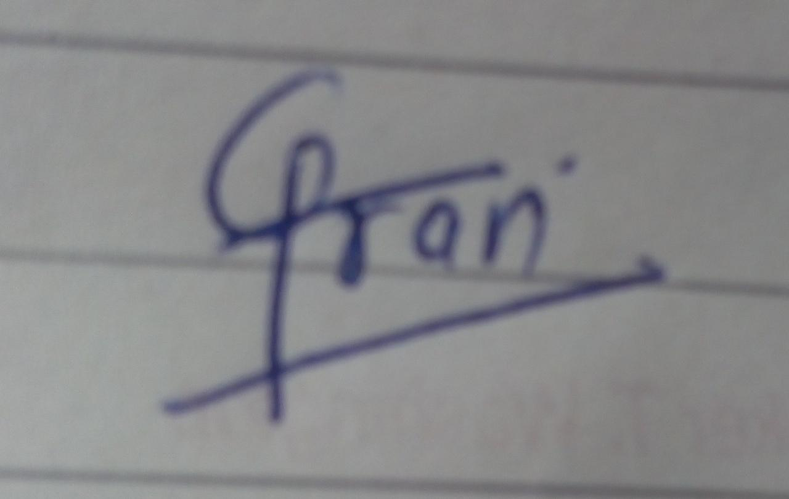  Name (In Block Letters): PRADIP GURAPPA CHAVAN | Date: 17/10/2021

Documents Required (Compulsory) | Attached Yes / No
Completed & Signed Application Form | Yes
Copy of Relevant Education Certificates | yes
One Passport Size Photograph | yes
Current Address Proof (if stay at current address > 6 months) else Longest Stay Address Proof.  Please note: Your name should be mentioned on the address proof.  Accepted address proofs: MTNL Bill / Electricity Bill/ Copy of Rent Agreement/ Passport/ Voter Id/ Driving License. | yes
Copy of all past Employment Appointment & Relieving Letters / Salary Slips with employee code | yes

